# Report 2: System Analysis & Architectural Design Report (Design Phase)

## System Overview

* The **Equipment Rental Management System** is designed to facilitate the renting of equipment by allowing staff to manage rental contracts, devices, inventory, and payment processes efficiently.
* The system enables customers to rent one or multiple devices, return them, and make payments either directly or through a designated owner.

**Target Users**:

* Staff (creating contracts, managing rentals)
* Owner (managing rentals, payments)

**Target Platform**:

* WPF Desktop Application (.NET 8)
* SQL Server Database

## UML Diagrams

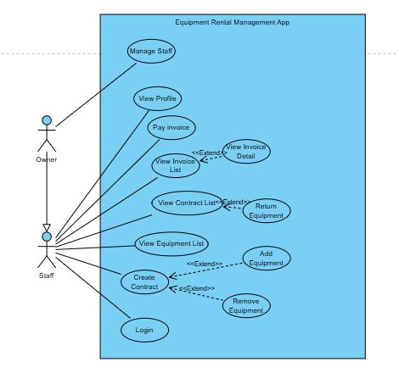

| **Use Case** | **Actor(s)** | **Use Case Description** |
| --- | --- | --- |
| Login | Staff/ Owner | As a Staff/ Owner, I want to log in so that I can access the system’s features. |
| Create Contract | Staff/ Owner | As a Staff/ Owner, I want to create a rental contract so that customers can rent equipment. |
| View Contract List | Staff/ Owner | As a Staff/ Owner, I want to view the list of contracts so that I can manage and monitor all rentals. |
| Return Equipment | Staff/ Owner | As a Staff/ Owner, I want to return rented equipment so that the contract can be completed. |
| View Equipment List | Staff/ Owner | As a Staff/ Owner, I want to view the list of equipment so that I can manage and check availability. |
| Add Equipment | Staff/ Owner | As a Staff/ Owner, I want to add new equipment so that it becomes available for rental. |
| Remove Equipment | Staff/ Owner | As a Staff/ Owner, I want to remove outdated or broken equipment so that the list stays up to date. |
| View Invoice List | Staff/ Owner | As a Staff/ Owner, I want to view all invoices so that I can track payments and statuses. |
| View Invoice Detail | Staff/ Owner | As a Staff/ Owner, I want to view detailed invoice information so that I can verify charges. |
| Pay Invoice | Staff/ Owner | As a Staff/ Owner, I want to process invoice payments so that the contract can be completed. |
| View Profile | Staff/ Owner | As a Staff/ Owner, I want to view my profile so that I can verify or update my personal details. |
| Manage Staff | Owner | As an Owner, I want to manage staff accounts so that I can maintain control over users and roles. |

## Database Design

* Relationship Diagram (ERD).
* 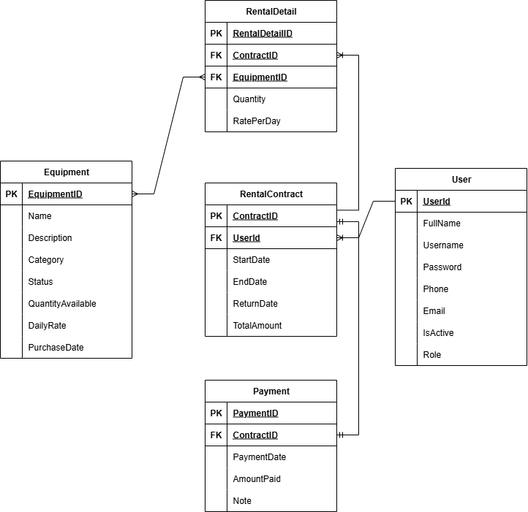

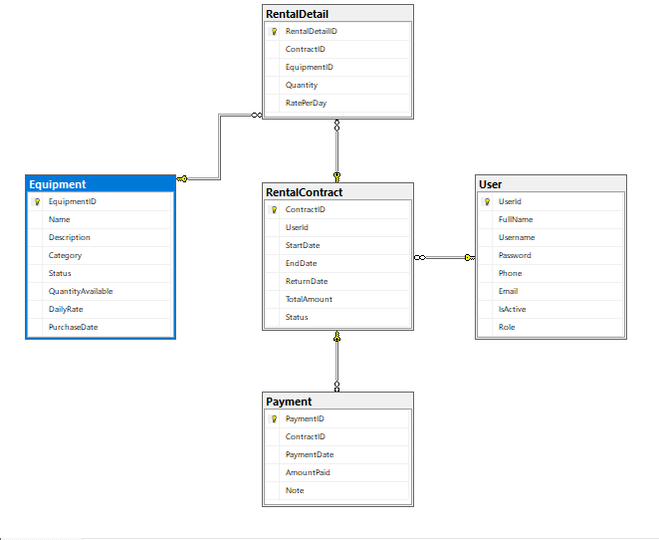

|  |  |  |
| --- | --- | --- |
| **No** | **Table** | **Description** |
| 01 | User | |  | | --- | | Stores user information (Staff, Owner) |  |  | | --- | |  | |
| 02 | RentalContract | |  | | --- | | Main table for rental agreements | |
| 03 | RentalDetail | |  | | --- | | Equipment rented under a contract |  |  | | --- | |  | |
| 04 | Equipment | |  | | --- | | Items available for rental |  |  | | --- | |  | |
| 05 | Payments | |  | | --- | | Payment transactions for invoices |  |  | | --- | |  | |

## User Interface (UI) Mockups

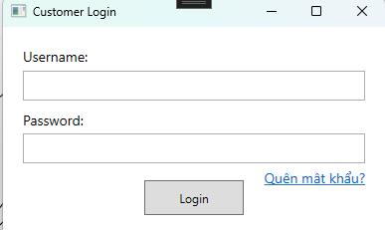

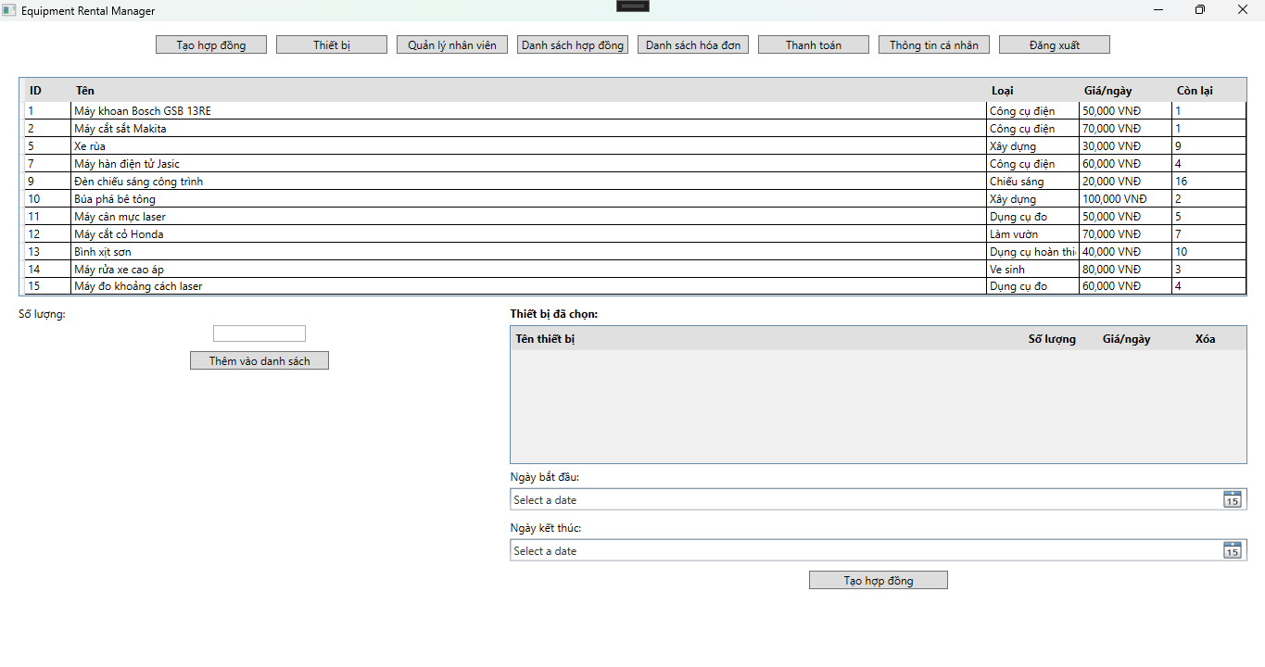

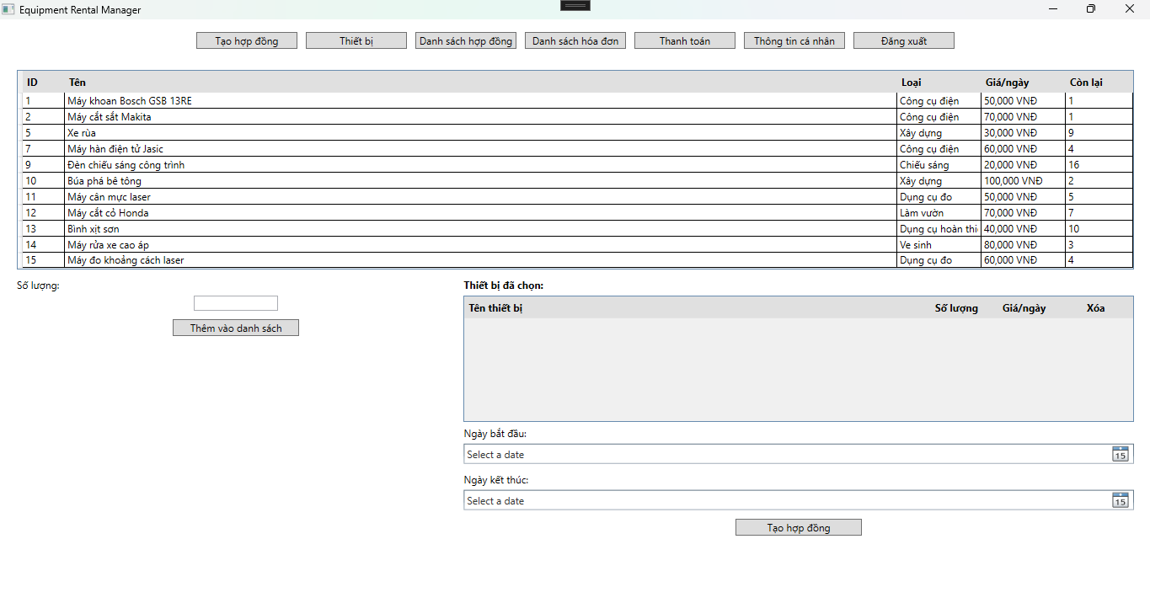

## CI/CD Planning

* CI/CD Tools

• **Version Control**: Git + GitHub

• **CI/CD Platform**: GitHub Actions

* Pipeline Overview

On push to main:

* Run build
* Run tests
* Deploy to local test environment

## Team Contributions

Phan Quyết Chiến - All